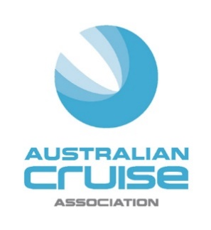

MEDIA STATEMENT
For Immediate Release
ACA Praises Cruise Sector for Bold Stance

(March 16, 2020) The Australian Cruise Association (ACA) has praised the numerous cruise lines which have made the unprecedented decision over the last few days to suspend their operations temporarily in Australia.
The ACA also supports the announcement by Prime Minister, Scott Morrison today, as part of its forward planning around Covid-19, to ban cruise ships from foreign ports arriving into Australian ports for a period of 30 days.
“We commend the cruise lines and the Australian Government for taking a proactive and co-ordinated stance at this time to help minimise the further spread of Coronavirus,” said Jill Abel, CEO of the ACA.
“We believe that the 30-day suspension on cruise ship entry is a reasonable response to the current situation which can be rolled out for longer depending on the spread of the virus.
“While this is an unfortunate turn of events, which directly impacts our members working in the diverse range of onshore support industries, the safety of all those associated with the cruise sector must remain our top priority,” Abel continued.
“We are also grateful to our members who assisted in the hosting of a number of ships into Australia over the last few months, whose itineraries had to divert around Asia. This allowed cruise passengers to enjoy their planned holidays and very importantly, supported those destinations impacted by the bushfires by providing much-needed economic input.
“But it is now time to make these difficult decisions in favour of the public health benefits and look forward to the long-term opportunity to get the industry back on its feet when the timing is appropriate.”
-ends-

Media Contacts:
Jill Collins
Barking Owl Communications
0417 654 474
Jill.collins@barkingowlcommunications.com.au

