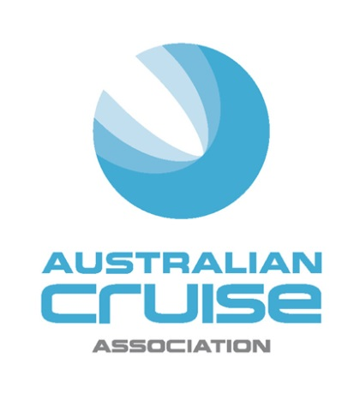

Media Release

For Immediate Release

New speakers and exciting social events announced for Australian Cruise Association
20th anniversary conference

(Hobart, 19 August, 2016) Three new speakers have been added, and the celebratory social events unveiled, for the 20th Anniversary Australian Cruise Association conference to be held in Sydney from September 7-9, 2016.

Adding to the international line-up of Edie Rodriguez, CEO Crystal Cruises and Bruce Anderson, Starcrest Consulting is Captain Michael McCarthy, Chair of Cruise Europe and Commercial Manager for the Port of Cork Company, Ireland. Michael will provide fascinating insight into the European cruise environment including the impact of recent political developments such as Brexit and increasing security threats.

Cruise industry pioneer, Ted Blamey, founder of Chart Management Consultants and long serving member of the Association will look at the highly important Asian region. Ted is an expert in this area having authored numerous white papers on the Asian cruise market.

Closer to home, Earthcheck GM, Consulting, Mark Olsen will discuss the importance of Destination Development and how the brand and identity need to deliver on the promise to meet visitor expectations.

Association CEO, Jill Abel will open the Conference with a look back at the highlights of the organisation to celebrate the theme "20 years - Our People, Our Passion, Our Success." Abel will then be joined at the podium by industry heavyweights Sandra Chipchase, CEO, Destination NSW and Grant Gilfillan, CEO Ports Authority NSW, joint sponsors of the Conference.

Emceed by Andrew McEvoy, Managing Director of Life Media and Events at Fairfax and Non-Executive Director at Sealink, this year’s speaker line-up will explore a range of topics critical to the growth of the cruise industry over the next 20 years including homeporting, infrastructure development, benchmarking and the regulatory landscape. A special focus on destination development will feature in the Destination and Ports workshop as the final session of the Conference.

A line-up of exciting celebratory social events will support the Conference program. Welcome drinks will be held the first night at the Overseas Passenger Terminal. The Gala dinner on Thursday night, sponsored by Abercrombie and Kent, will also be a highlight for attendees. It will begin with a fireworks display over Sydney Harbour followed by dinner at the Opera House Marquee presented by Aria catering. Guests will be treated to a menu designed by renowned Australian chef, Matt Moran showcasing the best of NSW produce.

The Conference is being held this year at the Four Seasons Hotel. For further information and registrations please go to http://www.australiancruiseassociation.com/conferences

-ends-

About Australian Cruise Association:
Australian Cruise Association is the co-operative marketing brand for cruise tourism in the Australia and Pacific region and represents a diversity of interests including regional ports, international, national and state tourism agencies, shipping agents, inbound tour operators and companies dedicated to marketing the region as a world class cruise destination.

Media Contacts:
Jill Collins
Barking Owl Communications
0417 654 474
Jill.collins@barkingowlcommunications.com.au

Jill Abel
Chief Executive Officer
Australian Cruise Association
0419 511 996
ceo@australiancruiseassociation.com

