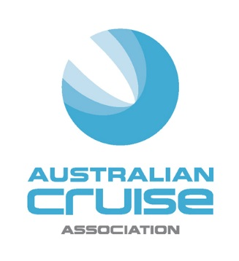

Media Release

For Immediate Release

Cruise numbers continue to ride a wave

(8 September, 2016) The economic value of the cruise industry to Australia continues to grow according to the figures released today by the Australian Cruise Association at their annual conference.

The Economic Impact Report, produced by independent research company, AEC Group, is now in its 12th year and reports on the changing economics of the cruise industry observing key indicators in context with the current environment.

This helps the Association and its members to better understand the size, growth and economic significance of the industry to the Australian economy to assist with future planning and strategy.

The 2015- 16 report noted growth in several significant areas of the cruise sector:
- 40 ports were visited in the last year - up from 31 in 2014-15. This is good news for the regional ports which are now seeing increased revenue from this source
- There were 2,762,000 passenger days in port – up from 2,400,000 last year
- Passenger and crew capacity on cruise ships has also shown an increase with 72,951 passenger capacity this year up from 68,134 in 2014-15, and crew capacity up from 29,582 to 31,230.
- Passenger expenditure increased to $1.069B from $903M the year before
- Crew expenditure also increased to $103M from $87M

A total of 46 cruise ships visited Australia in 2015-16 with ten new ships arriving into port including Azamara Quest, Costa Luminosa, Explorer of the Seas, Golden Princess, Le Soleal and Noordam. The industry also celebrated P&Os five ship spectacular last November which saw Pacific Aria, Eden and Venus visiting for the first time.

This growth curve will continue with eight new ships scheduled to arrive this year including Norwegian Star, Maasdam, Emerald Princess, Seabourn Encore, Azamara Journey, Magellan, Sirena and RCI’s Ovation of the Seas – the largest ship to ever cruise Australian waters which will kick off a maiden season for Australia and New Zealand this summer.
The economic impact of cruise ship visits to Australia is the aggregation of all international passenger and crew expenditure and cruise ship expenditure at each port visited by a cruise ship. In 2015-16 this direct expenditure totalled $1.734B.

This year, the Association asked AEC to closely examine the cost of bunkering (refueling in port) to identify more accurately the costs incurred by the cruise lines while they are in port. This continuous evaluation of the methodology behind the report gives increased rigour to the findings.

As such, AEC examined in detail the costs of the price of crude oil - which have dropped dramatically - and the improvements in fuel burn practices and new technologies onboard. This has resulted in reduced costs to the cruise lines but also decreased port-related expenditure. Long term the Association believes this will only provide increased growth as it becomes more cost efficient for cruise lines to visit Australia.

Jill Abel, Chief Executive Officer of ACA said: “We are excited by these figures which show that the cruise sector is continuing to be a vital growth industry for this country, with strong economic benefits for all involved and positive signs that Australian ports feature highly on cruise line itineraries.”

-ends-

About Australian Cruise Association:
Australian Cruise Association is the co-operative marketing brand for cruise tourism in the Australia and Pacific region and represents a diversity of interests including regional ports, international, national and state tourism agencies, shipping agents, inbound tour operators and companies dedicated to marketing the region as a world class cruise destination.

Media Contacts:
Jill Collins
Barking Owl Communications
0417 654 474
Jill.collins@barkingowlcommunications.com.au

