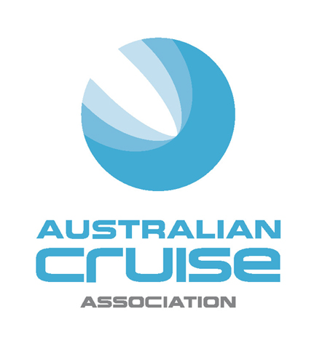
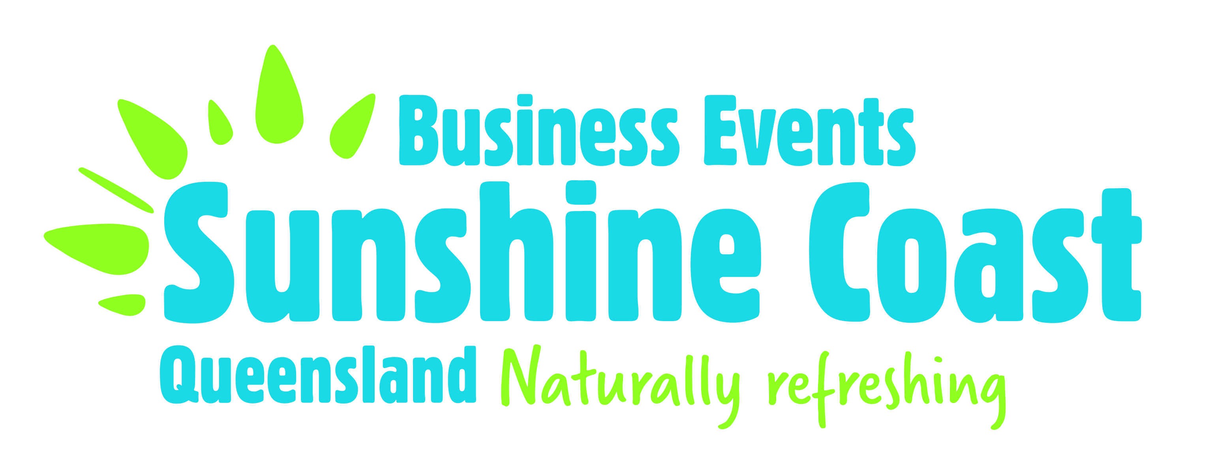

MEDIA RELEASE
For Immediate Release

Sunshine Coast shines as the selected venue for the
2017 Australian Cruise Association Conference

(Thursday 8 September, 2016) The Australian Cruise Association will hold their annual conference and AGM on the Sunshine Coast in September, 2017, reinforcing the region’s reputation as one of the fastest growing port destinations in the country.

The successful bid by Business Events Sunshine Coast (BESC) was announced at the completion of the 2016 Conference held in Sydney.

Making the announcement, Jill Abel, CEO of Australia Cruise Association said “We are seeing the regional ports becoming increasingly critical to the growth of the cruise tourism sector in Australia. We wanted to recognise that in our selection of the destination for our 21st annual conference next year and look forward to working with the Sunshine Coast on creating a highly successful event.”

It is anticipated that around 140 people will attend the Conference to be held 6 – 9 September 2017. This includes leading national and international cruise executives and representatives from the supply side of the cruise sector - shore excursion operators, port authorities, providores, shipping agents and tour businesses. The conference, AGM and associated functions will be held in Mooloolaba at host venues Mantra Mooloolaba Beach and The Surf Club Mooloolaba.

Commenting on the successful bid, Visit Sunshine Coast (VSC) CEO, Simon Latchford, said that hosting the Australian Cruise Association event was timely as the Sunshine Coast has gone from strength to strength as a popular destination for cruise itineraries, welcoming more than 24,000 passengers over the past two years.

“Cruising is the one of the fastest growing tourism sectors in Australia, which is why VSC, in partnership with Tourism and Events Queensland (TEQ) and Sunshine Coast Council (SCC) has identified growing and supporting the cruise sector as part of our tourism strategy,” said Mr Latchford.
“In 2015-2016 the cruise industry was estimated to have generated $1.2million in total expenditure for the Sunshine Coast with cruise ships integral to our tourism industry. There’s no doubt our swift growth in the cruise market can be attributed to our region’s beachside culture, local food, nature, attractions and the warm Sunshine Coast welcome from our friendly Visitor Centre volunteers and community.
“As a bonus, research indicates passengers who have a pleasurable experience during a stopover are likely to talk about the experience and return to the destination for a longer, dedicated visit in the future.
“This is another great example of the power of partnerships achieving great things together. BESC working with SCC, TEQ and tourism businesses to host the 2017 Australian Cruise Association Conference provides another opportunity for the Sunshine Coast to showcase our destination to influential cruise executives and industry representatives and highlights we are serious players in the cruise sector,” added Mr Latchford.

Tourism and Events Queensland CEO Leanne Coddington said the conference was an opportunity to further leverage the cruise market for the Sunshine Coast and Queensland.

“The emergence of Mooloolaba as a highly popular cruise destination has given domestic and international passengers another great reason to visit Queensland,” Ms Coddington said.

“We welcomed 329 vessels, a 20 per cent increase, to Queensland in the past year and this conference will further showcase the Sunshine Coast as a leading Australian cruise destination.”

Sunshine Coast Mayor Mark Jamieson said eight cruise ships from three different cruise lines had dropped anchor off Mooloolaba since July last year and in that short period of time our region had earned a reputation both domestically and internationally as a cruise ship stopover destination of choice.

“P&O’s Pacific Pearl was the first cruise ship to arrive and from that initial visit we received the highest passenger review of any port in Australia and the South Pacific,” Mayor Jamieson said.

“Earlier this year we welcomed five-star Royal Caribbean cruise ship Azamara Quest and guests from more than 20 different nationalities were absolutely thrilled by the warm welcome they received from Sunshine Coast businesses, tourism operators and the community during the day-long stopover.

“Council has worked hard to encourage and support the arrival of these cruise ships. It was fantastic to have the Pacific Pearl return here over the weekend and we’re looking forward to welcoming two more ships this year along with 11 next year and we already have four visits scheduled for 2018.

“Our local businesses and tourism operators have done an outstanding job in recognising the opportunities these visits present and with each arrival they’re getting better at showing guests a great time on the Sunshine Coast, from our coastal towns and attractions right up to the Hinterland.

“So on behalf of the Sunshine Coast community, I warmly welcome the 2017 Australian Cruise Association Conference and very much look forward to working with cruise executives, shore excursion and inbound tour operators and representatives from Australian and New Zealand cruise destinations during this event.”
The conference win follows a string of successful bids by Business Events Sunshine Coast including the Australian Event Awards and Symposium to be held on the Sunshine Coast from 21-23 September 2016 and the Australian Macadamia Industry Conference to be held 18-20 October 2016.
-ends-
For media enquiries:
Liz Tuckett, Visit Sunshine Coast
liz.tuckett@visitsunshinecoast.com | (07) 5458 8815 | 0417 345 050
Jill Collins, Australian Cruise Association
jill.collins@barkingowlcommunications.com.au | 0417 654 474

About Business Events Sunshine Coast (BESC)
BESC is the convention bureau for the Sunshine Coast. It sits as a dedicated unit within Visit Sunshine Coast, the regional tourism organisation for the Sunshine Coast. BESC is a not-for-profit, membership based organisation and their role is to promote the Sunshine Coast as a viable destination for conferences, meetings and incentive programs.
www.businesseventssunshinecoast.com

About the Australian Cruise Association
Australian Cruise Association is the co-operative marketing brand for cruise tourism in the Australia and the Pacific region and represents a diversity of interests including regional ports, international, national and state tourism agencies, shipping agents, inbound tour operators and companies dedicated to marketing the region as a world class cruise destination.
www.australiancruiseassociation.com
Sunshine Coast Cruise Schedule
2016
Pacific Pearl, 4 September
Pacific Jewel, 24 October
Pacific Pearl, 26 November
2017
Pacific Jewel, 6 January
Seabourne Encore, 30 January
Pacific Jewel, 22 February
Seabourne Encore, 8 March
Carnival Spirit, 7 May
Pacific Jewel, 28 May
Pacific Jewel, 1 August
Pacific Explorer, 2 August
Pacific Explorer, 21 August
Pacific Explorer, 28 August
Pacific Eden, 22 December

