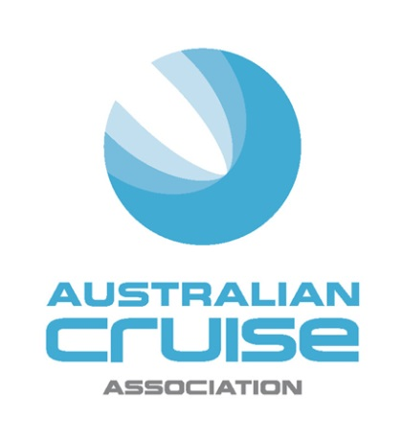

Media Release

For Immediate Release

Australian Cruise Association
20th anniversary conference and celebrations kick off in Sydney

(7 September, 2016) The Australian Cruise Association 20th anniversary conference and celebrations commenced in Sydney tonight and will run through September 9, 2016.

Themed "20 years - Our People, Our Passion, Our Success", the Conference will celebrate the role of the Association’s members in the successful growth of the cruise industry in this region and will explore the exciting opportunities for growth over the next 20 years.

Kicking off the celebrations was the “Flavours of NSW” welcome event at the Cargo Hall in the Overseas Passenger Terminal at Circular Quay. Jonathan O’Dea, NSW Parliamentary Secretary for Major Events and Tourism, officially welcomed delegates and invited them to enjoy produce from over 25 NSW food and beverage producers.

Mr O’ Dea said in his welcoming remarks “NSW continues to grow as a major international cruise destination, welcoming a record-breaking 322 cruise ship visits during 2015/16, with the number of ships expected to grow by 10 per cent this year.”

“As one of the world’s most dynamic and cosmopolitan cities, Sydney continues to position itself as the gateway to Australia, offering travellers an abundance of pre- and post-cruise ship options.”
“From the best in art, culture, food, shopping and vibrant events, the harbour city also provides for countless shore excursions to suit all tastes and budgets,” Mr O’Dea said.

The Conference sessions, emceed by Andrew McEvoy, Managing Director of Life Media and Events at Fairfax and Non-Executive Director at Sealink, open on Thursday, 8 September at the Four Seasons with a stellar line-up of speakers.

Association CEO, Jill Abel will open the Conference with a look back at the highlights of the organisation. Abel will then be joined at the podium by Mr O’Dea, and Philip Holliday, COO and Harbour Master Sydney, Port Authority of NSW to provide the official welcome. The Port Authority of NSW and the NSW Government’s tourism and major events agency, Destination NSW, are joint sponsors of the Conference.

This year’s speaker line-up reflects the coming of age of the industry and the Association. Edie Rodriguez, President and CEO of Crystal Cruises will give the keynote address. Ms Rodriguez is the first CEO of an international cruise line to speak at an ACA conference. She will speak on the luxury cruising segment, a topic she is well qualified to discuss having worked previously with Azamara Club Cruises, the upmarket division of RCL and for the Cunard and Seabourn brands while at Carnival.

Rodriguez is joined this year by other international experts - Bruce Anderson, Starcrest Consulting Group in Seattle will speak on environmental issues for the cruise industry including emissions reduction programs and Captain Michael McCarthy, Chair of Cruise Europe and Commercial Manager for the Port of Cork Company, Ireland will provide insight into the European cruise environment including the impact of recent political developments such as Brexit and increasing security threats.

Cruise industry pioneer, Ted Blamey, founder of Chart Management Consultants and long serving member of the Association will look at the highly important Asian region.
Matt McInnes, GM, Consumer Marketing, Tourism Australia will look at how the cruise sector plays an important role in their marketing outreach to attract global visitors. The international section closes with an update from newly appointed Chair of Cruise New Zealand, industry veteran, Debbie Summers.

Earthcheck GM, Consulting, Mark Olsen will headline presentations on the importance of Destination Development - a major focus for the Conference this year -. Olsen’s presentation on how a destination’s brand and identity need to deliver on the promise will be followed by a panel discussion with members from the Ports of Eden, Newcastle and Gladstone on the importance of cruising to their regions. Journalists, Sally MacMillan, Cruise Director for Fairfax newspapers and Rod Eime will present the passenger perspective with Eime focusing specifically on expedition cruising and sensitivities in journeying to small communities.

A range of topics critical to the growth of the cruise industry over the next 20 years including homeporting, infrastructure development, efficiency solutions, benchmarking and the regulatory landscape will round out the conference sessions.

Renowned Chef, Mark Best will provide a culinary highlight when he speaks before lunch on his role with the Culinary Council for Holland America Line. Best has also designed signature bites for attendees at the Conference lunch which showcase the on-board treats served to guests on the cruise line.

The Gala Dinner on Thursday night, sponsored by Abercrombie and Kent, will also be a highlight for attendees. John Sidoti, Parliamentary Secretary for Transport, Roads, Industry, Resources and Energy will attend the event. It will begin with a fireworks display over Sydney Harbour followed by dinner at the Opera Point Marquee presented by ARIA catering. Guests will be treated to a menu designed by renowned Australian chef, Matt Moran showcasing the best of NSW produce. Wines from See Saw in Orange and Glandore Estate in the Hunter Valley will feature at the event.

The Conference will continue on Friday with a very special breakfast starting the day. Young Australians of the Year, Nic Marchesi and Lucas Patchett will tell the story of how their organisation Orange Sky Laundry has grown from one van with two washer/dryers in Brisbane to an extensive operation across multiple locations offering mobile laundry services for the homeless.

The Conference will then move from its homebase at the Four Seasons to Carnival Spirit which will host a series of destination and port workshops to conclude the event.

-ends-

About Australian Cruise Association:
Australian Cruise Association is the co-operative marketing brand for cruise tourism in the Australia and Pacific region and represents a diversity of interests including regional ports, international, national and state tourism agencies, shipping agents, inbound tour operators and companies dedicated to marketing the region as a world class cruise destination.

Media Contacts:
Jill Collins
Barking Owl Communications
0417 654 474
Jill.collins@barkingowlcommunications.com.au

