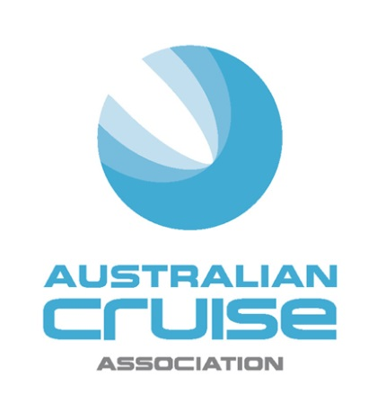

Media Release
For Immediate Release

NSW produce provides centrepiece at
Australian Cruise Association Conference

(31 August, 2016) NSW food and beverage producers will shine next week as the Australian Cruise Association holds its 20th anniversary conference in Sydney from September 7-9.

Kicking off the celebrations on Wednesday night, Destination NSW and the Port Authority of NSW will host Flavours of NSW at the Cargo Hall in the Overseas Passenger Terminal at Circular Qu ay. Over 25 producers from Sydney and NSW will gather to showcase their outstanding produce and experiences.

Some of the key producers include Pepe Saya and their renowned butter, Australia’s Oyster Coast serving freshly shucked oysters from the NSW South Coast, Zokoko Chocolate sampling single origin chocolate from the Blue Mountains and N2 Extreme Gelato serving a flash frozen gelato dessert designed exclusively for the event and featuring indigenous ingredients from regional NSW.

Guests can wash all this down with the help of Archie Rose Distillery who will be creating bespoke cocktails for the occasion and Dave’s Brewery Tours serving beers from six breweries across the state.

The following day, attendees will welcome a very special guest – renowned Australian chef, Mark Best (Pei Modern) will speak at the Conference on his role with the Culinary Council for Holland America Line. Best will showcase some of the on-board treats through a selection of signature bites which will be served at lunch.

The fun continues that night at the Gala Dinner, sponsored by Abercrombie and Kent, which will also be a highlight for attendees. It will begin with a fireworks display over Sydney Harbour followed by dinner at the Opera Point Marquee presented by ARIA catering. Guests will be treated to a menu designed by renowned Australian chef, Matt Moran again showcasing the best of NSW produce with wines supplied by cool climate vintners See Saw in Orange and Glandore Estate Wines in the Hunter Valley.

Buffalo mozzarella from Marrickville, whole roasted chicken from Tenterfield and wood roasted lamb from the Moran Family Farm, Bathurst will all be sure to delight the guests.

“Our goal this year was to reflect the high standard and wide range of produce, cruise passengers are now enjoying. From fabulous wines and craft beers to locally grown and raised meats, vegetables, fruits and dairy products – I am sure our Conference attendees will go away with a new appreciation of all that NSW has to offer” said Australian Cruise Association CEO, Jill Abel.

Each year the Association also pays tribute to a philanthropic organisation working in the Conference location. At the final breakfast this year, Orange Sky Laundry will discuss their successes and challenges providing the world's first free mobile laundry service for the homeless.

The Conference is being held this year at the Four Seasons Hotel and will see keynote speakers from Australia and around the world cover a range of topics critical to the fast growing cruise industry in Australia.

For further information and registrations please go to http://www.australiancruiseassociation.com/conferences

-ends-

About Australian Cruise Association:
Australian Cruise Association is the co-operative marketing brand for cruise tourism in the Australia and Pacific region and represents a diversity of interests including regional ports, international, national and state tourism agencies, shipping agents, inbound tour operators and companies dedicated to marketing the region as a world class cruise destination.

Media Contacts:
Jill Collins
Barking Owl Communications
0417 654 474
Jill.collins@barkingowlcommunications.com.au

